Rock—Paper—Scissors

The task: make the hub randomly display a rock, paper, or scissors.

Step 1: Attach LED Matrix to Hub
Let’s do the build.

Attach the LED matrix to the right side of the hub using two small black connectors.
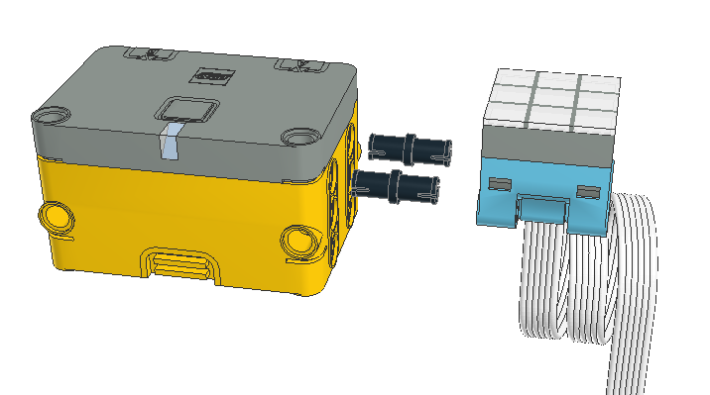

Connect the LED matrix to port A of the hub.
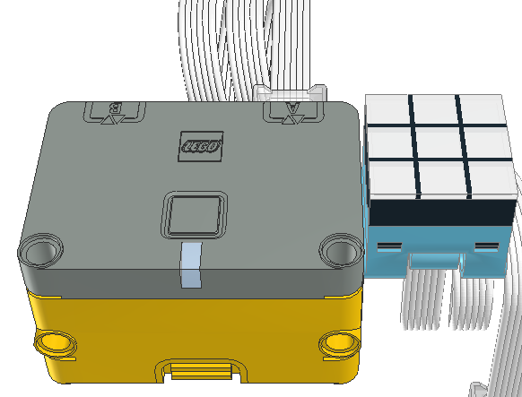

To prepare for programming. Turn on the host (Mac, iPad, PC), find the Spike App and start it.

When the app starts, select Spike Essentials on the left side of the window.
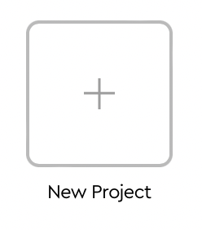
From the center portion the window, select the new project box.

Give the project a name, say “Rock-Paper-Scissors”.

Select word blocks.

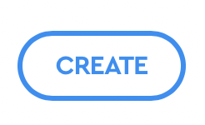
Click on the create button to open the programming window.

Press the Connect button in upper left and follow instructions to connect BlueTooth to the hub.

Step 2. Program Rock-Paper-Scissors
  Rock (A diamond) |   Paper (a sheet) | 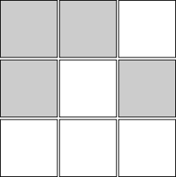  Scissors

Break the problem down into steps:

- Be able to display the three different things. Use three of the LED control blocks on the right. Test each one by clicking on the block and seeing the result.

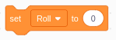
- select one of the three base on a roll variable

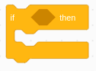
  - if ‘roll’ = 1, then display a rock

  - if ‘roll’ = 2, then display paper

  - if ‘roll’ = 3, then display scissors

- use a random number to set the roll variable


- Start the program by tapping on the hub.

- put it all together

Does it work as expected? No, can you fix it?

Can you improve it?

Can you add sounds for the sight impaired? Do your sounds make sense?

One Die

The task: Shake the hub to have it randomly show one side of a six sided die. (If you have more than one, it is two dice, three dice... If you have only one, it is one die. Yes, you only have the one.)

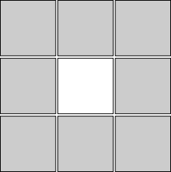  One pip (spot on the die) |   Two pips | 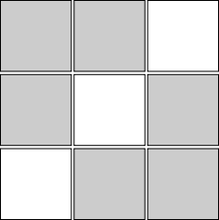  Three pips
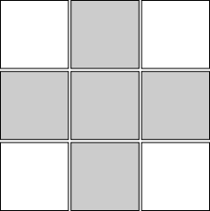  Four pips | 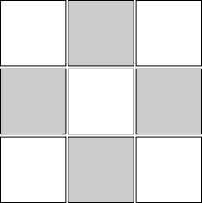  Five pips |   Six pips

Break the problem down into steps:

- Start with a shake

- Generate a random number between 1 and 6

- Set the value of a variable, say ‘roll’, to the number generated in step 2. Test this by monitoring the value of the variable with the right side slide over menu.

- Change the display based on the variable ‘roll’ from step 3.

  - if ‘roll’ = 1, then display 1 pip (a pip is a spot on a die)
  - if ‘roll’ = 2, then display 2 pips
  - if ‘roll’ = 3, then display 3 pips
  - if ‘roll’ = 4, then display 4 pips
  - if ‘roll’ = 5, then display 5 pips
  - if ‘roll’ = 6, then display 6 pips

Can you add sounds to count off the number of pips for the sight impaired?

Can you do it with a repeat block?

